DECO3801

Daredevil Gaming

UX Profile

Ethan Christie - 42587882

Alan Murtagh - 42038496

Chan-Yeop Jeong - 42859972

Yuchen Han - 42834803

Scott Bilkey - 42929615

William Wilesmith - 43012149

Online Collaborative Gaming

Table of Contents

List of Figures 2

List of Tables 2

1.0 Introduction 3

2.0 UX Goals 3

3.0 Primary User Research 4

3.1 Interview Transcript 4

4.0 Scenarios 5

4.1 First Encounter Scenario 5

4.2 Fringe Scenario 5

5.0 Comparable System Evaluation 6

5.1 Engagement 6

5.2 Immersion 6

5.3 Excitement 6

6.0 UX Evaluation Plan 7

6.1 Time to Action 7

6.2 Longevity 7

6.3 Immersion 8

6.4 Excitement 8

# List of Figures

Figure 1: SpaceCOG Main Menu 4

Figure 2: SpaceCOG Upgrade screen 4

Figure 3: Aaron playing our prototype 5

Figure 4: High fidelity mock-up 5

Figure 5: FTL ship upgrade screen 7

Figure 6: FTL shop screen 7

# List of Tables

Table 1: Time To Action test 7

Table 2: Longevity test 7

Table 3: Longevity questionnaire 7

Table 4: Immersion questionnaire 8

Table 5: Excitement questionnaire 8

# 1.0 Introduction

This UX profile is a short document that describes our ambitions for how our software will be experienced in use, and briefly outlines a plan for user evaluation during development and deployment.

It contains:

* A description of the user experience goals we envision for our game
* An interview with a primary user
* Two scenarios, one that describes somebody installing and playing our game for the first time and one that describes an extreme use situation
* An evaluation of a game somewhat similar to ours, FTL: Faster Than Light.
* An evaluation plan for our system.

# 2.0 UX Goals

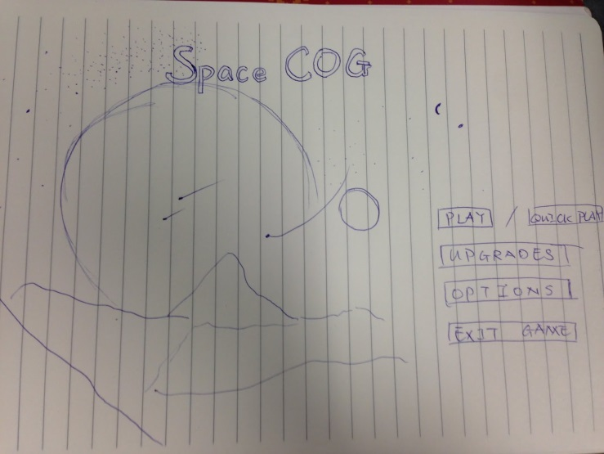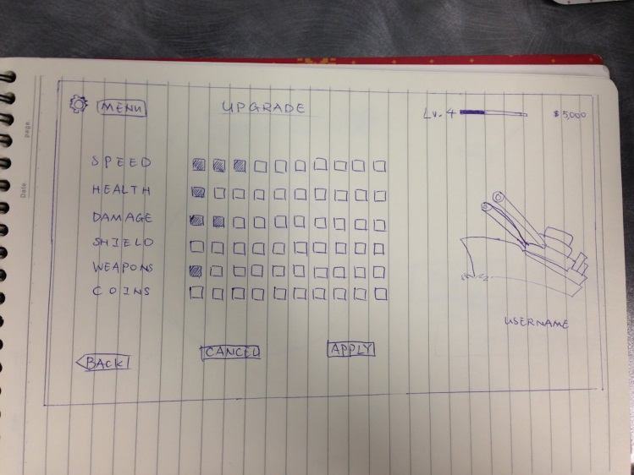The first goal of our system is to create an **engaging** user experience.  We intend to initially grab the user’s attention by providing them with a fun game which they can quickly play and immediately get into action, then providing a rich experience and level-up system to engage the user, providing incentive to continue earning gold.  This mechanic has been tried and tested in countless other games, for example, Dungeons and Dragons, World of Warcraft and FTL: Faster Than Light.

Figure 1: SpaceCOG Main Menu

Figure 2: SpaceCOG Upgrade screen

We also hope to create an **immersive** experience for the user.  We intend to do this by engineering sound effects, or otherwise sourcing them under a Creative Commons license.  Additionally, the game will have a rich and vast background of space, creating an immersive world.

Lastly, we want to create **exciting** experience for the user.  Being a space shooter game, we hope that the user’s adrenaline will be pumping due to near misses and difficult fights.  Additionally, we intend to achieve this goal by using a mechanic such that it can pay off to backstab your allies to some extent.

# 3.0 Primary User Research

For our user research, we developed a small-scale version of our game to test the co-operation/backstab mechanic of our game. It is a small script that plays a game of 10 rounds against 5 computer opponents. Each round, a player can choose to co-operate or backstab. If they choose to backstab, one random player dies. Then, if enough players survived, the mission will pass and a reward is split between the survivors. After 10 rounds, the scores are tallied and the player with the most points wins.

Aaron Smith is a university student who loves to play games in his spare time. We showed him this prototype and a high-fidelity mock-up of our final system and asked him for his input.

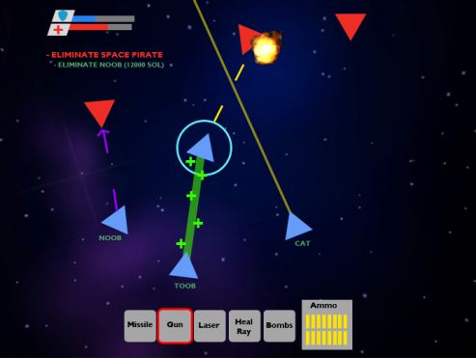

Figure 3: Aaron playing our prototype

Figure 4: High fidelity mock-up

## 3.1 Interview Transcript

Interviewer*:**So, what did you think of the backstabbing mechanics?*

Aaron Smith: **It was cool, but I would really like it if you could choose who to backstab. Also, if you knew how many people you needed to beat a mission, then players could strategize team play and backstab or cooperate at the right time, instead of leaving it to chance.**

I: *Here is an early mockup of the game screen. What do you think about the look of the game?*

AS: **It looks ok; Toob is healing that guy who seems to have a shield?**

I: *Actually, that’s meant to be representing the player selected*

AB: **Ok, that should probably change as it looks like an energy shield or something. The font colour could be changed? Maybe not. I don’t know. What’s SOL?**

I: *SOL is the game’s currency*

AB: **Oh, ok. So, the player has made an objective to kill Noob and will get SOL from it?**

I: *Actually, those are random objectives that occur during missions to entice the player to betray their team members for money. What do you think about that?*

AB: **It’s fine since it’s not forcing the player to betray their team.**

# 4.0 Scenarios

In this section, we describe two scenarios. The first is a “first encounter” scenario, in which a user downloads, installs and plays our game for the first time. The second is a “fringe” scenario where players are joined together in a match with significant skill difference

## 4.1 First Encounter Scenario

Alex is a junior civil engineer who loves to play games in his spare time. He is a recent graduate from university, and just started his first career. He used to play computer games and video games often with his friends while he was in high school and university. The moment he got his first career, his free time is now dramatically reduced. He purchases SpaceCOG because he heard the gameplay time is short.

To do this, he navigates to the SpaceCOG Greenlight page on Steam and installs it through their software. It downloads from the Steam servers and is ready to play.

Alex starts SpaceCOG by double clicking its entry in his Steam library. A tutorial guides him through the basics of the game before he joins a lobby to play online. He clicks “Play”, selects a lobby to join and waits for it to fill before the game starts.

He dies on his first play-through by taking too much damage from the AI ships. His team finishes the mission without him and they split the reward three ways, but Alex has learned better how to avoid damaging shots in the future.

## 4.2 Fringe Scenario

Mona and Lisa have just gotten home from work and decided to wind down by playing some SpaceCOG. They both joined a random lobby together with a couple of other players; everyone seems to be new and rather low levelled. However; before the mission starts, another player with the handle “PlayerX" joins and indicated by their level, it appears they are an experienced player.

Once the mission starts the other players’ voice their complaints about letting a high level player join the mission, who could turn on them at any moment and kill them with relative ease. They decide to disconnect immediately and Mona and Lisa are left alone with PlayerX, who in fact, is offering his assistance to lower level players to help them progress and level up in the game. With the other players gone, Mona and Lisa will get a larger share of the reward at the end and are extremely pleased by the fact that the mission will be significantly easier to complete with a higher level player helping them out.

They are able to complete the objectives quickly and with little trouble, however; their last objective is to fight a large boss who calls waves of enemies alongside. PlayerX warns the two that they aren’t confident they will be able to defeat the boss without their help.

During the boss fight Lisa accidentally fires a missile towards PlayerX and it does massive damage. PlayerX is surprised and confused and in the middle of combat it turns into anger, PlayerX then turns on Mona and Lisa and a deathmatch commences in the middle of the boss fight. Unfortunately, Mona and Lisa are destroyed by PlayerX, who is shortly destroyed by the boss, and they fail the mission.

# 5.0 Comparable System Evaluation

In this section, the game **FTL: Faster Than Light** will be evaluated using the UX goals stated above as criteria.

## 5.1 Engagement

FTL achieved this goal by starting the player off at a low difficulty and gradually ramping up.  The skill ceiling is relatively high, which means a player can usually improve the efficiency of their play irrespective of their skill level, thus progressing further through the next run.  Additionally, players can unlock ship upgrades. This mechanic and the “roguelike” random map generation are both features that improve replayability and thus engage the player.

## 5.2 Immersion

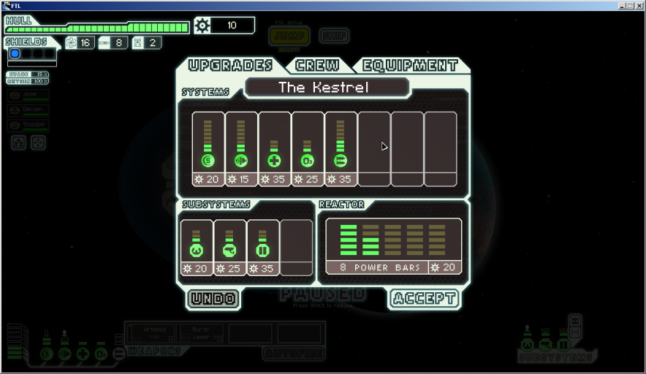FTL achieved this with a catchy tune and its simple yet elegant graphic style. Its vast array of choices enables the user to get lost in thought about which way they can upgrade their spacecraft.

Figure 5: FTL ship upgrade screen

## 5.3 Excitement

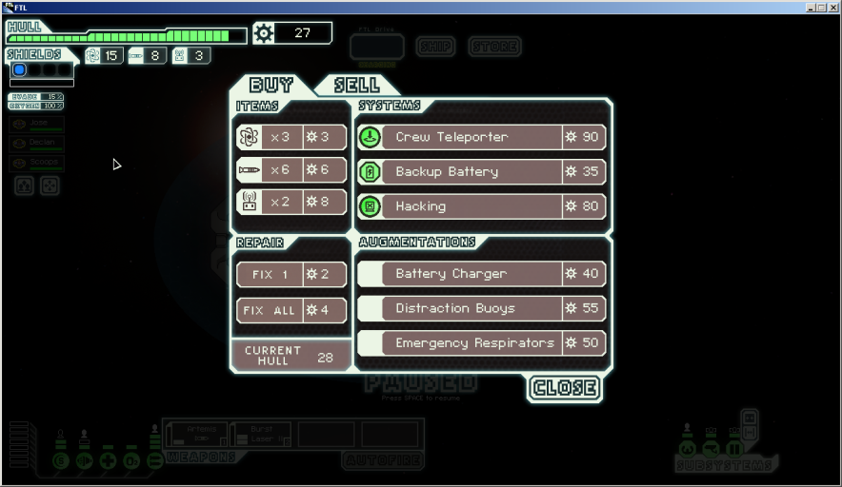FTL achieved this in a different way than in SpaceCOG.  By limiting resources, the player is forced to make a choice between survivability and damage output. Additionally, the aforementioned random map generation helps to achieve this goal.

Figure 6: FTL shop screen

.

# 6.0 UX Evaluation Plan

In this section, we describe a plan to carry out evaluation of a User Experience. Periodically, we will perform these tests on new users, record the results and adjust the gameplay based on these results.

## 6.1 Time to Action

As stated in our UX goals, an important contributor to engagement is that they can very quickly begin playing. For us, this comes down to two major factors:

1. How long it takes a new user to create an account; and
2. How long it takes to go from the splash-screen to the beginning of a round of gameplay.

For each of the above, we will use heuristic evaluation methods to ensure that both are achievable within a maximum acceptable timeframe when used by experienced users.

We will also perform observational studies on a handful of entirely inexperienced users, to ensure that the user interface is clear and intuitive enough to guide them to where they want to be within a maximum acceptable timeframe.

Table 1: Time To Action test

|  |  |  |  |
| --- | --- | --- | --- |
| Criteria | Result | Acceptability | Success |
| Developer: time to create a new account. |  | <120 seconds |  |
| Developer: time from splash to gameplay. |  | <30 seconds |  |
| User: average time to create new account. |  | <120 seconds |  |
| User: average time from splash to gameplay. |  | <60 seconds |  |

## 6.2 Longevity

Another key contributor to user engagement is their desire to play additional rounds after their first ones. The game needs to stay fresh, and to allow the user to continually discover new things. Our character progression system is intended for this purpose.

We will need to perform observational studies to ensure that advancement occurs quickly enough to remain interesting, but slowly enough to keep players hooked for at least 20 hours of play. We will also need to conduct user interviews to determine whether the progression incentives are exciting enough to keep them engaged.

Table 2: Longevity test

|  |  |  |  |
| --- | --- | --- | --- |
| Criteria | Result | Acceptability | Success |
| Progression extrapolation: time for 100% completion. |  | >20 hours |  |
| Progression extrapolation: first advancement within a maximum average time. |  | <30 minutes |  |

Table 3: Longevity questionnaire

|  |  |
| --- | --- |
| Questionnaire | Answer |
| Which advancement are you most excited for? |  |
| Which advancement are you least excited for? |  |
| In general, do you feel the advancements are interesting? |  |
| How do you feel about the rate of progression? |  |
| Do you want to play more? |  |

## 6.3 Immersion

Whilst we don’t have the resources to develop a game with cutting-edge graphics or sounds, it should be within our abilities to create a game that is aesthetically pleasing and interesting. Due to the subjective nature of this aspect, the only way to evaluate our artistic assets will be to undertake usability testing and interviews with users.

Table 4: Immersion questionnaire

|  |  |
| --- | --- |
| Questionnaire | Answer |
| Overall, how would you rate the visual appeal of the game? |  |
| Did you find any of the graphics to be visually jarring? Which ones? |  |
| Overall, how would you rate the game’s sound effects? |  |
| Did you find any of the sound effects to be jarring? Which ones? |  |
| Overall, how would you rate the game’s music? |  |

## 6.4 Excitement

One of the core aims of this game is to provide a tense and exciting experience, where players distrust each other, and feel like everything they do matters. We expect that the core gameplay mechanics lend themselves quite well to this end, but the only way to be sure will be to perform frequent usability tests and observational studies of our users, and adjust the gameplay accordingly.

Table 5: Excitement questionnaire

|  |  |
| --- | --- |
| Questionnaire | Answer |
| How often did you feel like your decisions were irrelevant? |  |
| How strongly did you feel a sense of distrust for your teammates? |  |
| Overall, was the game fun? |  |
| What was your favourite aspect of the game? |  |
| What would you change to improve the game? |  |
| Would you feel excited to tell your friends? |  |